**Logistic Regression POC**

**Implementation:**

Applied multiple logistic regression to identify a fraud detection data model by preparing the mock data of Real Time transactions say ATM/POS/ECOM channels.

**Data Source:**The below data-source is being used for our LOGISTIC REGRESSION Model.



**Dataset Analysis:**If we observe the below mock data holds the information of transactions.

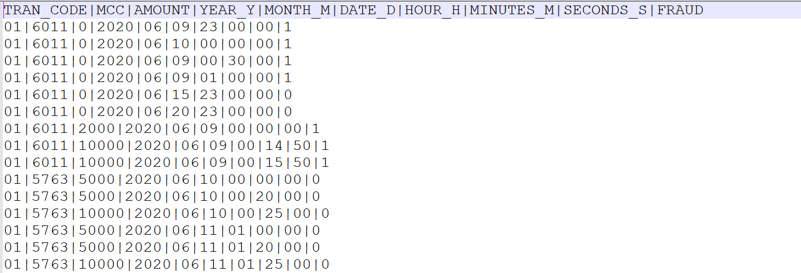

**Group By(Independent Variable):**

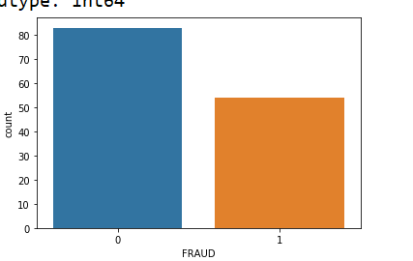

**Confusion Matrix:**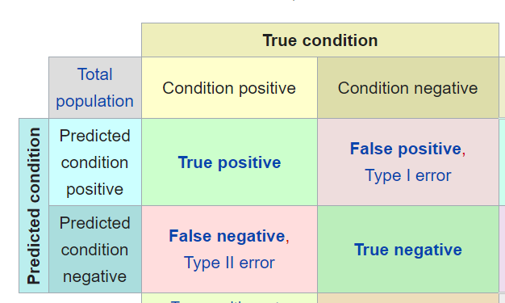

**Confusion Matrix Result:**

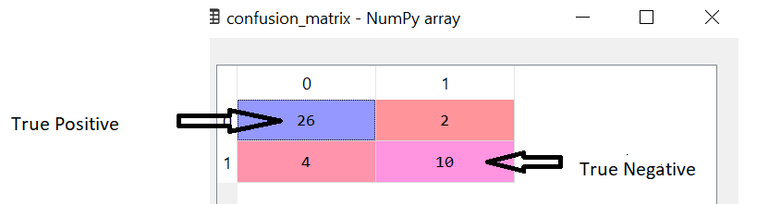

**Accuracy:**  
Our Logistic Regression model throws **86%(round-off)** accuracy in the mock dataset prepared.

